Press release

EJCAP Spring issue 2017: Companion animal rehabilitation
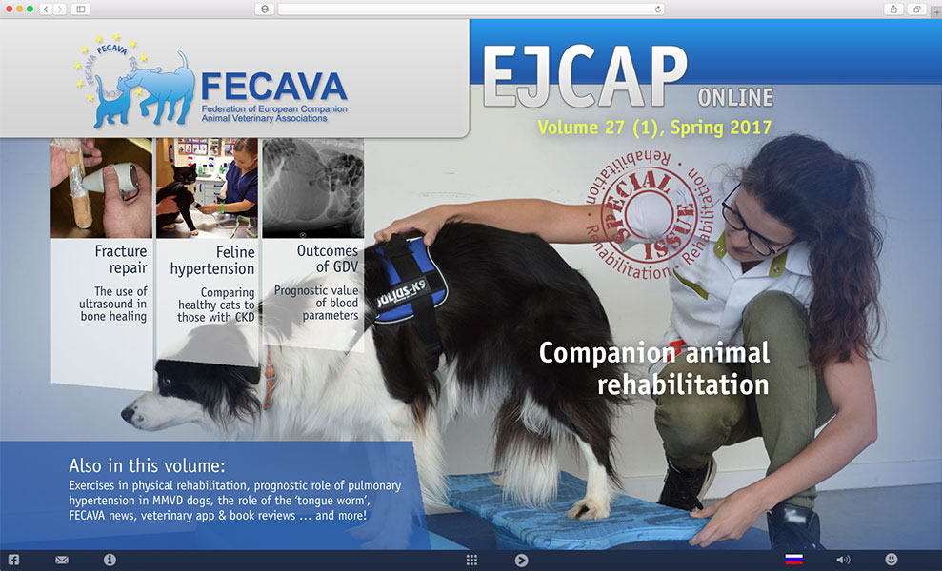
15 March 2017 – From hydrotherapy to shockwaves and from laser treatment to cold packs – the range of physical therapeutic options to aid in the healing and rehabilitation of our patients are extensive.
Yves Samoy and colleagues from Belgium provide an overview of currently available tools and techniques in the latest issue of the European Journal of Companion Animal Practice.
The issue also contains interactive papers on hypertension in cats with chronic kidney disease (Esther Bijsmans et al), prognostic variables in dogs with GDV (Joyce Verschoof et al) and the link between pulmonary hypertension and congestive heart failure (Michele Borgarelli et al). Test your knowledge with the interactive quizzes!

‘How to...’ – power podcasts
‘How to use hydrotherapy’ (Donna Carver) and ‘How to take nasal biospies’ (Ben Harris) are presented in the highly popular powerpoint & podcast series of BSAVA congress lecture recordings.
The myth of the ‘tongue worm’ is debunked in a paper by Ana Faustino from Portugal, while the FECAVA news page presents the new working group on Vector-borne diseases and the Didier Carlotti Medal.

Veterinary app & book reviews
Finally, the issue contains the quarterly review of apps of use for the small animal practitioner (this time, apps on cardiology, tick prevalence and a handy scanning tool) and books (on arthropod infections, veterinary anaesthesia and echocardiography).

Published four times a year, the spring issue of 2017 is now available online at www.ejcap.org.
Access is open to all veterinary practitioners, students and nurses in Europe and beyond, and is compatible for viewing on tablets. Please visit www.ejcap.org for more details.

Notes for Editors

• EJCAP is the official organ of the Federation of European Companion Animal Veterinary Associations (FECAVA), the platform for the promotion of the professional development and representation of companion animal veterinarians in Europe. Founded in 1990, it currently has 40 national member associations and 13 associate member associations. FECAVA represents over 30,000 companion animal practitioners throughout Europe.

• EJCAP online (www.ejcap.org) is generously supported by Hill’s Pet Nutrition, its prime partner.

• For further information, please contact EJCAP’s Editor Karin de Lange

